Dear Student,

As you may know, <INSTITUTION> has partnered with the Charles Schwab Foundation and EverFi to deliver the Schwab MoneyWise® on Campus financial education program to our students. Schwab MoneyWise® on Campus is a fun, easy way to boost your financial know-how and put yourself on a path to success while in college and beyond. The program provides students with access to EverFi’s Transit program, which guides you through real-life financial situations that you may encounter while in school, and helps you build a personalized action plan to manage your personal finances.

As part of our comprehensive prevention program for new students, <INSTITUTION> expects you to complete the Transit Financial Wellness course.

Your login directions and additional details are included in this communication.

<If you are requiring the course, this is a good place to state your incentives/punitive measures. Using terminology noting the course is required has been found to yield greater student participation. >

PLEASE READ THE FOLLOWING CAREFULLY:

You are expected to complete Transit Financial Wellness. You will need one EverFi Higher Education Account to access the course from your Dashboard.

To fulfill <INSTITUTION’S> requirement:
- Go to: http://www.everfi.com/login and click “Register”
- Under “Student/Learner,” enter the Registration Code: <REGISTRATION CODE HERE> and click “Next” to create your EverFi Account
    - <If requesting student ID, include this additional language> Note: When prompted, please enter your <#-DIGIT STUDENT ID> to receive credit for completion. You can look-up your Student ID <insert custom language here>.
- Complete Part 1 of <COURSES> by <DATE>
- After 30-45 days you will receive an invitation to complete Part 2 of Transit, which must be completed by <DATE>

*If you already have an EverFi Higher Ed Account, go to http://www.everfi.com/login, enter your login information, then enter registration code <REGISTRATION CODE HERE> by clicking “Add a Course” in the top right corner of the Dashboard.

Transit Financial Wellness |  | Course Outline
Registration Code | <Code> | 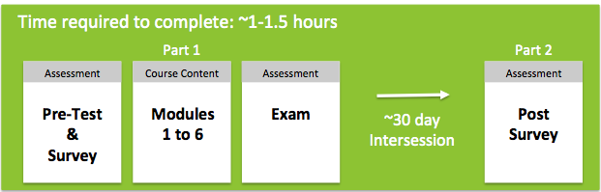
Course Opens | <date>
Part 1 Due | <date>
Part 2 Due | <date>
Exam Passing Score | 70%

Other Important Information:
- You will need Internet access and audio capabilities.
- To avoid technical issues, please use any major web browser released within the previous two years.
- You may take the course in multiple sittings.
- The course may include surveys to help personalize your experience and measure students’ attitudes and behaviors. All survey responses are confidential; the school will only receive information about the student body as a whole and will never see individual students’ answers.
- Should you experience problems, technical support is available 24/7 and can be accessed from the “Help” link within the course.

Thank you, and enjoy the course!
Sincerely,
<INSTITUTION>

